The Seas Have Lifted Up Their Voice
September 11, 2017

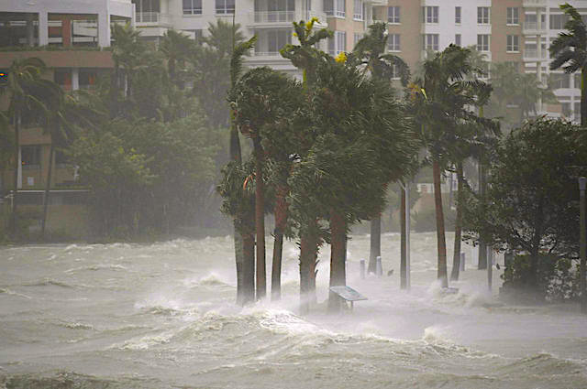
May these words of encouragement from Jesus keep us steady at the helm, as He makes changes in the direction this country is going in. Amen.

Well, with the Hurricane and all, you would think the message would be doom and gloom. Far from it. I was really surprised when the Lord began speaking to me. I had to do a double, triple discernment just to be sure it was Him, because I'd never heard Him like this before!

Jesus began, "We are winning. We are winning!" Jesus said with a smile.

"All Glory and honor to God…we are winning.

"Continue in prayer and fasting—continue, My Dove, don’t let up. If only you knew the power of your prayers, you would not waste one moment of your day not praying. 'Pray unceasingly' was not just a quaint injunction. It was an important exhortation. Since the beginning of the anointing of My apostles, the enemy began siege works against Me and against them. Remember what I said to Peter, 'Satan has desired to sift you but I have prayed…'

"You see, with Me living inside of you, your prayers are powerful, like Mine. Oh, never underestimate the power of prayer. You are going to see major changes because you prayed first.

"Give, always give. Do not let a need pass you by without doing something to help. This is another powerful protection against the enemy’s permissions to steal from you. As I entrust to you, give to others with their own encouragement—that when they can to give to others as well, they should. And the Kingdom of God will be built up in your midst.

"Nothing is impossible to the soul that will pray, because nothing is impossible to God. My Father is continually listening for the prayers of His little ones, because He desires to answer them. Even the littlest prayer of a child carries tremendous influence before the Throne, because of their innocence.

"Continue to pray, My People. We are gaining the edge and I tell you the truth, these hurricanes are no accident. Though contrived by evil men, they shall fall back on them in a way they never saw coming."

Interestingly, I got a rhema, Psalm 93. And it really caught my attention. It was right on the heels of this message.
The seas have lifted up, Lord,
the seas have lifted up their voice;
the seas have lifted up their pounding waves.
Mightier than the thunder of the great waters,
mightier than the breakers of the sea—
the Lord on high is mighty. Psalm 93:3-4

Amen! He hasn't given me the specifics of what's going on. But He has said that we are winning, that we need to press in and keep up what we are doing. And not slack off.

God bless you, precious Heartdwellers. Thank you for your prayers, your mighty prayers. They are so important. I know it seems like a little thing, 'cause we're just little people. But with the Lord living in us, they're mighty prayers. Very mighty prayers. Be encouraged. We are reaching a goal, thanks to your intercession.

The Lord bless you.

